**It’s perfect timing for optical frequency combs**

**– from clocking chips to imaging blackholes**

*Korea Advanced Institute of Science and Technology (KAIST), Korea*

**Jungwon Kim**

**Email:** [**jungwon.kim@kaist.ac.kr**](mailto:jungwon.kim@kaist.ac.kr)

Optical frequency combs, with their unique features in both the time and frequency domains, have transformed precision science and engineering over the last two decades. In this talk, I will present on the latest progress in the ultralow-noise frequency combs and their applications, focusing particularly on precision timing, synchronization, and microwave/mm-wave photonics. We have successfully demonstrated mode-locked fiber lasers and silica micro-combs with quantum-limited timing jitter. We have also developed methods to stabilize the timing of these comb sources using compact and robust fiber photonic techniques. Leveraging such ultralow-noise, compact and robust comb sources, we have demonstrated new timing applications including laser-RF-THz synchronization for ultrafast science facilities, attosecond electronic pulse timing, on-chip clock distribution networks, ultrafast and sub-nm-precision time-of-flight sensors, 3D dynamic imaging of mechanical micro-resonators, and microwave/mm-wave generation and phase calibration for VLBI radio telescopes.

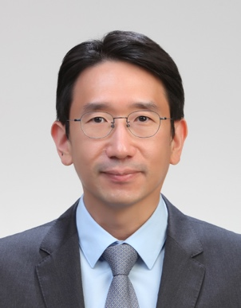**Short Bio:**

**Jungwon Kim** received the B.S. degree in electrical engineering from Seoul National University in 1999, and the S.M. and Ph.D. degrees in electrical engineering and computer science from MIT in 2004 and 2007, respectively. In 2009, he joined the faculty of the Korea Advanced Institute of Science and Technology (KAIST), where he is currently a professor of mechanical engineering and adjunct professor of electrical engineering and semiconductor systems engineering. His research interests are optical frequency combs and their applications in timing and synchronization, microwave/mm-wave photonics, ultrafast 3D imaging, photonic signal processing, and industrial metrology. Dr. Kim is a Fellow of Optica (formerly OSA), a Senior Member of IEEE, a Topical Editor of Optics Letters, and was one of the 2024 IEEE Photonics Society Distinguished Lecturers.