**Laser Technology for Development of Advanced Batteries**

*Institute for Applied Materials – Applied Materials Physics (IAM-AWP), Karlsruhe Institute of Technology (KIT), Germany*

**Wilhelm Pfleging**

**Email: wilhelm.pfleging@kit.edu**

Laser technologies and processes are increasingly being used in battery manufacturing and related application-oriented research and development. While laser welding is already well established in battery module production and high-speed electrode cutting is increasingly being integrated into production lines, there are other laser-based processes that can not only increase cost efficiency and processing speed, but also have a targeted impact on electrochemical performance characteristics. The development of novel electrode concepts for high-performance lithium-ion batteries of the next generation has been initiated as a new research field at KIT, which has already met with a broad response and is being imitated internationally in the field of research as well as in industrial pre-development. Here, methods of laser-assisted structuring of electrodes and current collectors are used and optimized to set specific electrochemical properties in batteries. For example, battery lifetime, fast charging capability, and battery safety can be significantly improved. The 3D electrode concept developed has also improved thick-film concepts for high-energy cells to such an extent that user-friendly charging and discharging rates are now possible, i.e., high energy and high-power densities can now be realized in lithium-ion batteries at the same time. The presentation gives an overview of the current state of development work at KIT in the field of 3D batteries and an outlook on process upscaling for future industrial use.

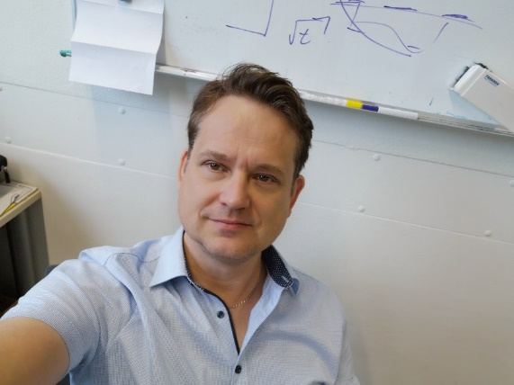**Short Bio:**

Prof. **Wilhelm Pfleging** is Head of the Laser Materials Processing Group at the Institute of Applied Materials, which is part of the Karlsruhe Institute of Technology (KIT). He received and his Ph.D. in Physics from the University RWTH Aachen University (Germany) at the Fraunhofer Institute for Laser Technology. He has published more than 200 peer-reviewed articles in scientific journals, books and conference proceedings. His research focuses on the development of laser-assisted processes, analytics and fabrication of advanced lithium-ion batteries and related energy storage materials. Since his habilitation in 2019 and his professorship in 2022, his teaching field at the KIT university is "Laser Technology".