**Applications of fs laser micro-processing of transparent materials**

*Zhejiang University, China*

**Jianrong Qiu**

**Email: qjr@zju.edu.cn**

Femtosecond laser is an extreme physical condition. It has been widely used for additive, subtractive and equal material manufacturing due to its ultra-short laser pulse and ultrahigh light intensity. When a transparent material e.g. glass is irradiated by a tightly focused femtosecond laser, the photo-induced reaction occurs only near the focused part of the laser beam inside the glass due to the multiphoton processes. In this talk, we will describe what happened during and after the fs laser irradiation in transparent materials, some observations of interesting phenomena, e.g. precipitation of bandgap tunable nanocrystals and formation of periodically distributed nanocrystals etc. The mechanisms and promising applications of these phenomena are also discussed.

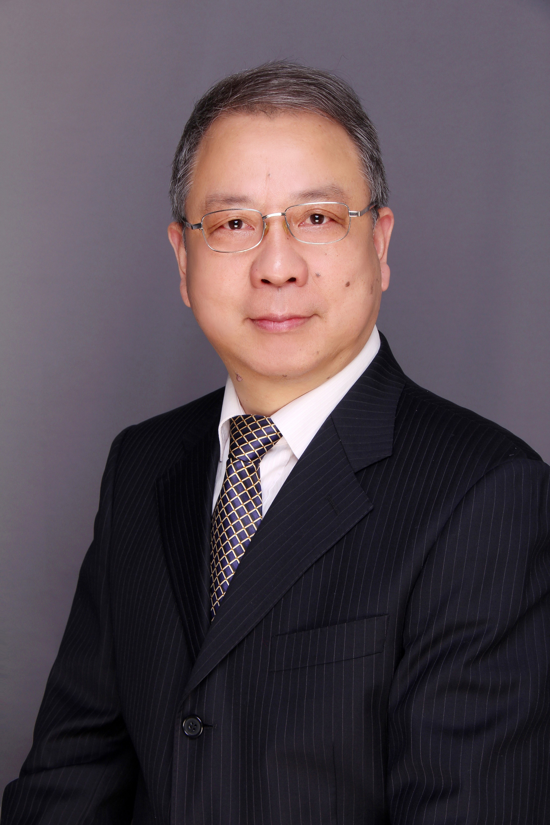

**Short Bio:**

**Jianrong Qiu is a professor of Zhejiang University, China. He is fellow of Optica and the American Ceramic Society, academician of the European Academy of Sciences.**