**Thin Film Lithium Niobate Electro-Optic Devices and Ultralarge-Scale Photonic Integration**

*Shanghai Institute of Optics and Fine Mechanics, CAS, China;*

*East China Normal University, China*

**Ya Cheng**

**Email: ya.cheng@siom.ac.cn**

The recent advancement in thin film lithium niobate (TFLN) photonic integration technology has been rapid, driven by profound physical, material, and technological factors. Single-crystalline TFLN is particularly noteworthy for offering the most comprehensive performance solution to date, addressing long-term challenges in low transmission loss, high-density integration, and low modulation power consumption under the context of photonic integrated circuits (PICs). Notably, a broad range of high-performance TFLN devices have been demonstrated using the photolithography assisted chemo-mechanical etching (PLACE) technique which is specifically developed for the mass-production of large-scale PICs. In this talk we will report our recent progresses of the PLACE technique, accompanied by its application in developing current high-performance cutting-edge electro-optic devices and ultralarge-scale photonic integration systems, including on-chip tunable delay lines, electro-optically programmable photonic circuit, waveguide lasers and amplifiers. These TFLN photonic devices are now approaching industrial optical performance standards, opening opportunities for next-generation optical information technology development.

**Short Bio:**

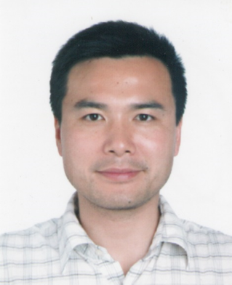**Ya Cheng** is a Professor of East China Normal University and Shanghai Institute of Optics and Fine Mechanics, CAS. His research focuses on ultrafast nonlinear photonics and femtosecond laser micromachining. He has been granted more than 30 Chinese invention patents and 8 US patents, and published more than 300 peer-viewed papers. He has also published 5 books in English, and 1 book in Chinese. Additionally, he has given more than 150 invited talks at various international conferences. He is an Optica Fellow, a Fellow of Institute of Physics, UK, and a Lifetime Fellow of International Association of Advanced Materials.