**New technologies with light: from chip fabrication to quantum information**

*Department of Physics, The Hong Kong University of Science and Technology*

**Sen Yang**

**Email: phsyang@ust.hk**

Light has been greatly used in solid based technologies. Here we would like to show two fields. One is the direct laser writing method based on the semiconductor opto-electronic properties of semiconductor particles. This method can greatly simplify the fabrication process of electronic devices. The other is the applications and developments based on nitrogen vacancy centers in diamond in quantum physics, such as quantum memory for quantum communications, quantum computing nodes and various quantum sensors.

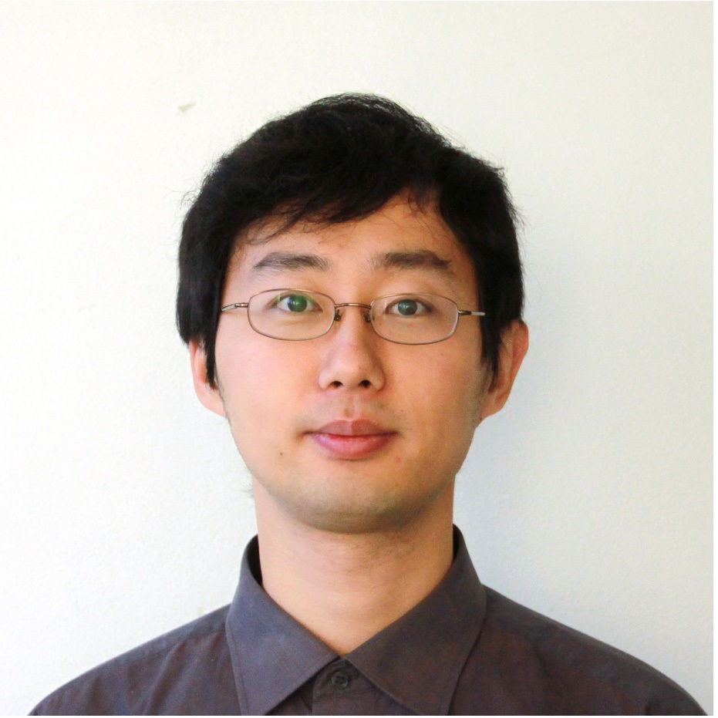**Short Bio:**

**Sen Yang** is an associate professor in the department of physics, the Hong Kong University of Science and Technology. He got his B.S. from Tsinghua University and Ph.D. in University of California, San Diego.